**E-commerce Customer Segmentation MySQL QUERY DOCUMENT**

**Customer Segmentation | SUMMARY : BY Shivanand S Nashi**

**Q1.How many rows have missing or null values?**

**SELECT COUNT(*) AS Missing_Rows**

**FROM cust_data**

**WHERE Gender IS NULL OR Orders IS NULL;**

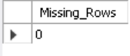

**Q2. What percentage of customers have missing gender information?**

**SELECT**

**COUNT(*) AS Missing_Gender_Count,**

**(COUNT(*) * 100.0 / (SELECT COUNT(*) FROM cust_data)) AS Percentage**

**FROM cust_data**

**WHERE Gender IS NULL**

**LIMIT 0, 1000;**

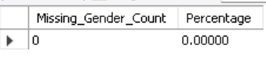

**Q3.What is the distribution of customers by gender?**

**SELECT Gender, COUNT(*) AS Cust_ID**

**FROM cust_data**

**GROUP BY Gender;**

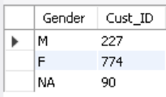

**Q4.Who are the top 10 customers based on the number of orders?**

**SELECT Cust_ID, Orders FROM cust_data ORDER BY Orders DESC LIMIT 10;**

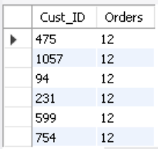

**Q5.Which brands are the most popular?**

**SELECT 'Jordan' AS Brand, SUM(Jordan) AS Total**

**FROM cust_data**

**UNION ALL**

**SELECT 'Gatorade', SUM(Gatorade)**

**FROM cust_data**

**UNION ALL**

**SELECT 'Samsung', SUM(Samsung)**

**FROM cust_data**

**UNION ALL**

**SELECT 'Asus', SUM(Asus)**

**FROM cust_data**

**UNION ALL**

**SELECT 'Udis', SUM(Udis)**

**FROM cust_data**

**ORDER BY Total DESC**

**LIMIT 5;**

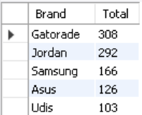

**Q6.How many customers have missing gender information?**

**SELECT Cust_ID FROM cust_data WHERE Gender IS NULL;**



**Q7.Do male and female customers differ in the average number of orders placed?**

**SELECT Gender, AVG(Orders) AS Avg_Orders FROM cust_data GROUP BY Gender;**

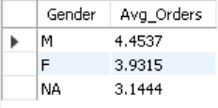

**Q8.How many customers have not placed any orders?**

**SELECT COUNT(*) AS Zero_Orders_Customers**

**FROM cust_data**

**WHERE Orders = 0;**

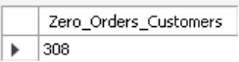

**Q9.What is the total number of orders placed by all customers?**

**SELECT SUM(Orders) AS Total_Orders**

**FROM cust_data;**

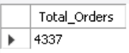

**Q10.Which brand has the highest total purchases?**

**SELECT**

**'Jordan' AS Brand, SUM(Jordan) AS Total_Purchases**

**FROM cust_data**

**UNION ALL**

**SELECT 'Samsung', SUM(Samsung)**

**FROM cust_data**

**UNION ALL**

**SELECT 'Gatorade', SUM(Gatorade)**

**FROM cust_data**

**ORDER BY Total_Purchases DESC**

**LIMIT 1;**



**Q11. Are there significant gender-based differences in preferences for specific brands?**

**SELECT Gender, SUM(Jordan) AS Jordan_Purchases, SUM(Samsung) AS Samsung_Purchases**

**FROM cust_data**

**GROUP BY Gender;**

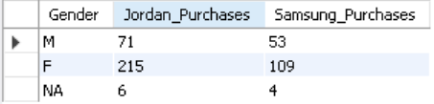

**Q12. Who are the top 5 customers based on total brand purchases?**

**SELECT Cust_ID, (Jordan + Gatorade + Samsung + Asus + Microsoft) AS Total_Brand_Purchases**

**FROM cust_data**

**ORDER BY Total_Brand_Purchases DESC**

**LIMIT 5;**

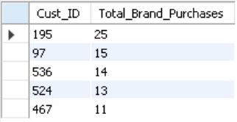

**Q13. How many customers purchased items from more than one brand?**

**SELECT Cust_ID, Brand_Count**

**FROM (**

**SELECT**

**Cust_ID,**

**CASE WHEN Jordan > 0 THEN 1 ELSE 0 END +**

**CASE WHEN Samsung > 0 THEN 1 ELSE 0 END +**

**CASE WHEN Gatorade > 0 THEN 1 ELSE 0 END -- Add more brand columns as needed**

**AS Brand_Count**

**FROM cust_data**

**) AS Brand_Data**

**WHERE Brand_Count > 1;**

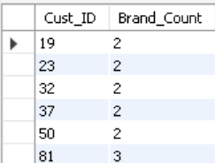

**Q14. Who are the customers placing orders above the average count?**

**SELECT Cust_ID, Orders**

**FROM cust_data**

**WHERE Orders > (SELECT AVG(Orders) FROM cust_data);**

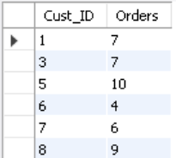

**Q15. Is there a strong correlation between the number of orders and brand purchases?**

**SELECT Cust_ID, Orders, (Jordan + Samsung ) AS Total_Brand_Purchases**

**FROM cust_data;**

